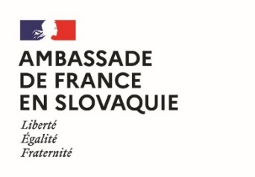 | 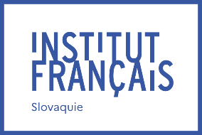 | 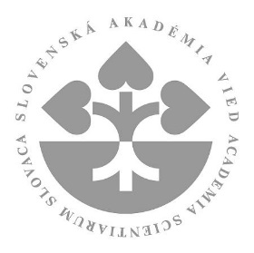 | 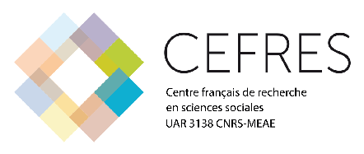

Joint Fellowships of the French Government
and the Slovak Academy of Sciences
in the field of humanities and social sciences
2023 edition

The French Embassy in Slovakia, the French Institute of Slovakia and the Slovak Academy of Sciences, in cooperation with the French Centre for Research in Social Sciences (CEFRES) and the French research group "Connaissance de l’Europe médiane" (Knowledge of East-Central Europe, see cem.hypotheses.org), are offering a programme to support scientific stays in the field of humanities and social sciences in France during the year 2023. This programme is intended for young researchers working in institutes and centres of the Slovak Academy of Sciences. The objective of this programme is to support Slovak-French cooperation in this field through a two-month research stay with the scientific support of the French partner, teams of CEFRES and members of CEM. Consequently, applications will be submitted individually by young researchers, but the support from members of CEFRES and CEM will be an essential element of their evaluation.

The ambition of the programme is to create sustainable research synergies between French and Slovak partners working in collaborative networks on innovative and interdisciplinary research topics in humanities and social sciences.

Benefits:
These scholarships offer the following benefits:
- A stipend from the French Embassy in Slovakia, the French Institute of Slovakia and the Slovak Academy of Sciences, the amount of which will depend on the status of the candidate and will range from 1704€ to 2055€ per month, for two months;
- Assistance in finding accommodation by the French agency Campus France.

Expected outcomes:
- A presentation of the results at the CEFRES seminar of the collaboration following the stay in France will be expected before the end of 2023 (in situ or online; CEFRES will cover the travel and accommodation costs of the speaker in Prague).
- The organisation of a seminar (research and/or doctoral training) to be held in Slovakia. No financial support will be given for the organisation of the seminar in Slovakia and the search for adequate funding will be the responsibility of the applicant.
- The beneficiaries of the exchanges in the framework of the joint scholarships of the French government and the Slovak Academy of Sciences will be encouraged to apply to the CNRS’ IEA funding tools (https://international.cnrs.fr/wp-content/uploads/2020/06/Fiche-IEA-2020.pdf) with recommended scientific theme "Constructing, deconstructing, exploiting fear: an interdisciplinary place". However, applicants may propose their own theme.

Application schedule:
- Opening date of the call for applications: 16 January 2023
- Deadline for submission of applications: 17 April 2023
- Interviews with applicants: 5 May 2023
- Publication of results: 12 May 2023
- Period for the stay in France: from 1 June to 30 November 2023
- Seminar in Slovakia: from 1 January to 31 December 2024.

Contact information:
Prior to submitting the application, the candidates shall contact Michal Kšiňan, Member of the SAS Presidium, email: ksinan@up.upsav.sk. Applications should be sent to: Yan Pautrat, Attaché for scientific and academic cooperation, French Institute in Slovakia, email: yan.pautrat@diplomatie.gouv.fr

Conditions for eligibility:
The call for proposals is open to researchers who hold PhD. degree (or equivalent) and have defended their doctorate at most eight years before submitting their application, who do not hold French nationality and who work at an institute or centre of the Slovak Academy of Sciences. Knowledge of the French language will be considered an asset but is not a requisite for application.

Evaluation criteria:
Applications will be evaluated by the joint committee of experts created by the CEFRES-SAV cooperation agreement. Candidates will have to present both an interdisciplinary scientific cooperation project and a seminar project (research and/or doctoral training) to be held in Slovakia that would lead to the submission of an International Emerging Actions project between the National Centre for Scientific Research and the Slovak Academy of Sciences, in partnership with the Prague CEFRES. The evaluation will take into account both
- the applicant’s individual scientific record;
- the scientific quality of the project to which the proposed scientific stay will contribute;
- the scientific quality of the proposed seminar that the applicant would organise in Slovakia, and its impact on the scientific cooperation between the Slovak Academy of Sciences, the CEM and CEFRES.

Scientific fields:
All areas of the humanities and social sciences are eligible but the recommended theme is: "Constructing, deconstructing, exploiting fear: an interdisciplinary space".

Content of applications:
Applications should include, in either English or French:
- The attached information sheet;
- A curriculum vitae of the candidate researcher;
- A presentation of the scientific project on innovative and interdisciplinary research topics, mentioning the dates planned for the stay (2 pages maximum);
- A presentation of the seminar to be held in Slovakia and its expected impact (1 page);
- A letter of authorisation from the director of the Slovak host institute or centre, preferrably describing their support for the application and for organisation of the seminar, written in either French or English;
- A letter of invitation from the director of the French host organisation, preferably describing their support for the application, written in either French or English (could be delivered once application is accepted).

