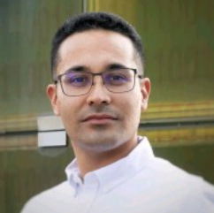
Hosť programu Mobility visit: Jorge Sánchez Arciniegas, Valencia, Spain

Štvrtok 29.01.2026 o 10:30
Seminárna miestnosť
Pavilónu lekárskych vied BMC SAV
ORCID: 0000-0002-0824-2691
Mathematical Modelling of Cardiac Electrophysiology: From Equations to Patient-Specific Predictions
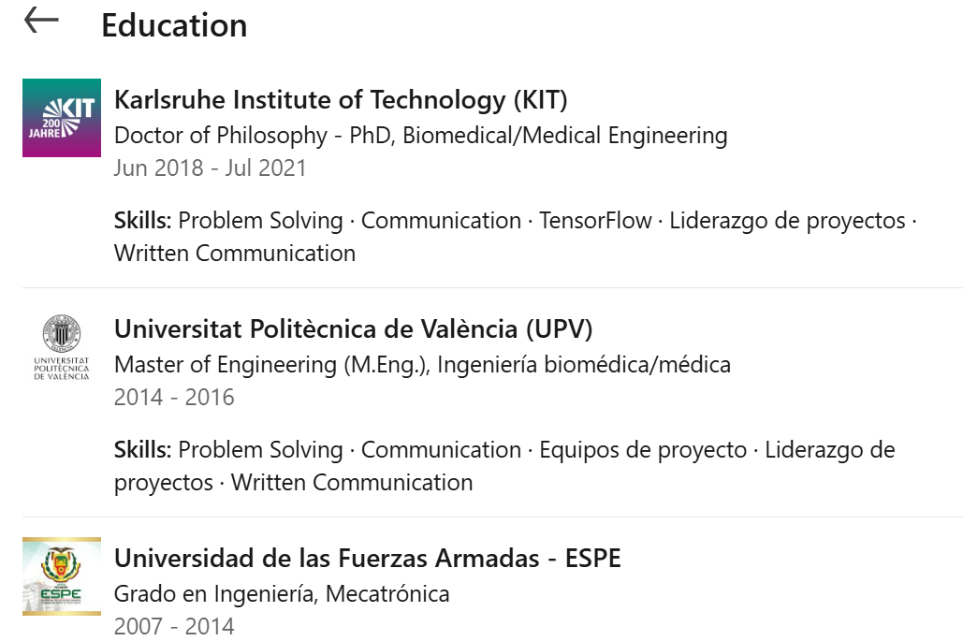

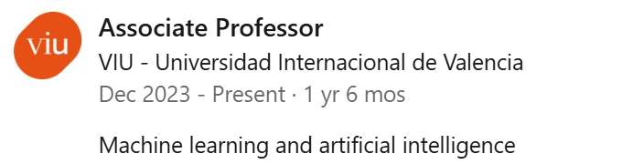
Abstract:
Mathematical modelling provides a principled way to connect cardiac structure, biophysics, and clinical data to explain normal and pathological physiology. In this talk, I will introduce key models used in computational cardiology, from reaction–diffusion formulations of electrical propagation to models of cardiac mechanics and electromechanical coupling, as well as simplified (0D/1D) representations of hemodynamics, highlighting how these frameworks can be calibrated and validated using patient-specific information. I will also present a pipeline for building subject-specific models (geometry, tissue properties, boundary conditions, and functional readouts) and discuss how simulations can be used to interpret mechanisms of arrhythmias and to explore in silico scenarios relevant to therapy planning. Finally, the presentation will outline current challenges and opportunities for reproducibility, uncertainty quantification, and clinical translation.
Education

