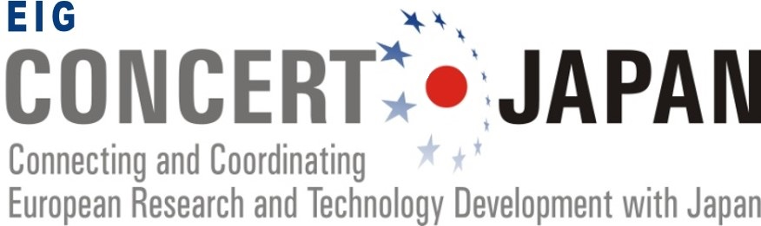

Form for Online Expert Evaluators:
Design of Materials with Atomic Precision Joint Call

Required skills to become an online evaluator:

- Skills and knowledge appropriate to the relevant scientific and technological field of the Joint Call (see the Thematic Area Description of the Joint Call available on the EIG CONCERT-Japan website).

- Appropriate English language skills.

- A proven experience in one or more of the following areas of activities:
- Management or evaluation of S&T projects,
- International cooperation in S&T,
- Use of the results of research and technological development projects,
- Technology transfer and innovation.

Evaluation framework:

- Period: From Friday, 5 August 2022 to Friday, 16 September 2022.
- Estimated number of projects to be evaluated by each expert: 3 to 5.
- Remuneration: €50 per proposal (transfer made by the JST).
- Assessment tool: Online evaluation system (PT-Outline).

Please fill all sections of this document and send it with your CV to the Joint Call Secretariat:
concert-japan-jcs@cnrs.fr

The deadline to send your application as an online evaluator is 20 June, 2022.

The Joint Call Secretariat will then assign project proposals to online evaluators according to areas of expertise and keywords. Please note that your application may not be selected if it appears that your profile does not correspond to the submitted projects.
In all cases, the Joint Call Secretariat will keep you informed.

Personal details

Title | Choisissez un élément. |  |  | Family Name | Cliquez ici pour taper du texte. | First Name | Cliquez ici pour taper du texte.
Email address |  | Cliquez ici pour taper du texte. |  |  |  | Phone number |  | Cliquez ici pour taper du texte.
Nationality |  | Cliquez ici pour taper du texte.
Organisation |  |  | Cliquez ici pour taper du texte.
Department |  |  | Cliquez ici pour taper du texte.
Address |  |  | Cliquez ici pour taper du texte.

Current work situation

Describe your current work position and responsibilities

Language skills

English  Please evaluate your language level between 1 and 10 | Choisissez un élément.

Experience

Do you have experience in one or more of the following areas of ACTIVITIES?
☐ Management or evaluation of Science and Technology projects,
☐ International cooperation in Science and Technology,
☐ Use of the results of research and technological development projects,
☐ Technology transfer and innovation.

Please provide a short description of your experience

Area of expertise

dEscribe in a short paragraph your area of expertise

Keywords

Select the most relevant keywords related to you’re area of expertise
- ☐ Atomic-scale simulation

- ☐ Biomedical applications

- ☐ Chemical analysis

- ☐ Composite materials

- ☐ Computing and semiconductor applications

- ☐ Functional materials

- ☐ Inorganic chemistry

- ☐ Materials analysis/measurement

- ☐ Material computational science

- ☐ Materials engineering

- ☐ Nanomaterials

- ☐ Nanostructure

- ☐ Organic chemistry

- ☐ Physical analysis/testing

- ☐ Physical chemistry

- ☐ Quantum materials

- ☐ Surface science

Free Keywords / COMMENTS

