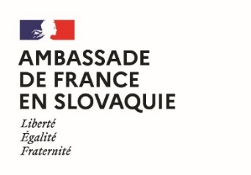 | 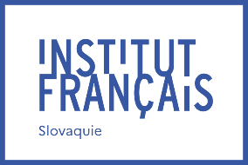 | 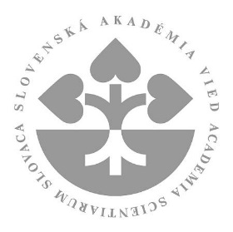 | 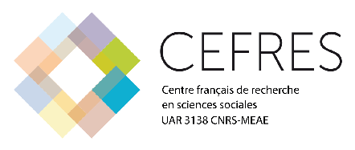

Joint Mobility Grant of the French Government
and the Slovak Academy of Sciences
in the field of humanities and social sciences
for young researchers, edition 2024

The French Embassy in Slovakia, the French Institute of Slovakia and the Slovak Academy of Sciences, in cooperation with the French Centre for Research in Social Sciences (CEFRES), are offering a programme to support scientific stays in the field of humanities and social sciences in France during the year 2024. This programme is intended for young researchers working in Institutes and Centres of the Slovak Academy of Sciences. The objective of this programme is to support Slovak-French cooperation in this field through a two-month research stay in France. Consequently, applications will be submitted individually by young researchers.

The ambition of the programme is to create sustainable research synergies between French and Slovak partners working in collaborative networks on innovative and interdisciplinary research topics in humanities and social sciences.

Benefits and funding:
These mobility grants offer the following benefits:
- A financial support from the French Embassy in Slovakia and the French Institute of Slovakia the amount of which will depend on the status of the candidate and will range from 1704€ to 2055€ per stay;
- A financial support from the Slovak Academy of Sciences of 2000 euros per stay;
- Assistance in finding accommodation by the French agency Campus France.

Expected outcomes:
- A presentation of the results at the CEFRES seminar of the collaboration following the stay in France will be expected before the end of 2024 (in situ or online; CEFRES will cover the travel and accommodation costs of the speaker in Prague).
- The organisation of a seminar (research and/or doctoral training) to be held in Slovakia before June 2025. No financial support will be given for the organisation of the seminar in Slovakia and the search for adequate funding will be the responsibility of the applicant.
- The beneficiaries of the exchanges in the framework of the joint mobility grant of the French government and the Slovak Academy of Sciences are expected to apply to the CNRS’ International Emerging Actions funding tools (https://international.cnrs.fr/wp-content/uploads/2020/06/Fiche-IEA-2020.pdf).

Application schedule:
- Opening date of the call for applications: 1 December 2023
- Deadline for submission of applications: 15 February 2024
- Interviews with applicants: during the week of 26 February 2024
- Publication of results: March 2024
- Period for the stay in France: from 1 May to 30 November 2024

Contact information:
Prior to submitting the application, the applicants shall contact Michal Kšiňan, Member of the SAS Presidium, email: ksinan@up.upsav.sk. Applications should be sent to:
- Yan Pautrat, Attaché for scientific and academic cooperation, French Institute in Slovakia, email: yan.pautrat@diplomatie.gouv.fr
- Please include in CC Michal Kšiňan ksinan@up.upsav.sk, Claire Madl, deputy director at CEFRES, claire.madl@cefres.cz

Conditions for eligibility:
The call for proposals is open to researchers who hold PhD. degree (or equivalent) and have defended their doctorate at most eight years before submitting their application, who do not hold French nationality and who work at an Institute or Centre of the Slovak Academy of Sciences. Knowledge of the French language will be considered an asset but is not a requisite for application.

Evaluation criteria:
Applications will be evaluated by the Joint SAV - CEFRES Expert Committee and funding of the project will be approved by the SAS Presidium. Applicants will have to present both an interdisciplinary scientific cooperation project and a seminar project (research and/or doctoral training) to be held in Slovakia that would lead to the submission of an International Emerging Actions project between the CNRS and the Slovak Academy of Sciences, in partnership with the Prague CEFRES. The evaluation will consider:
- the applicant’s individual scientific record;
- the scientific quality of the project to which the proposed scientific stay will contribute;
- the scientific quality of the proposed seminar that the applicant would organise in Slovakia, and its impact on the scientific cooperation between the Slovak Academy of Sciences, the CNRS and CEFRES.

Scientific fields:
All areas of the humanities and social sciences are eligible.

Content of applications:
Applications should include, in either English or French:
- The attached information form;
- A curriculum vitae of the applicant;
- A presentation of the scientific project on innovative and interdisciplinary research topics, mentioning the dates planned for the stay (2 pages maximum);
- A presentation of the seminar to be held in Slovakia and its expected impact (1 page maximum);
- A letter of authorisation from the director of the Slovak host institute or centre, preferably describing their support for the application and for organisation of the seminar, written in either French or English;
- A letter of invitation from the director of the French host organisation, preferably describing their support for the application, written in either French or English (could be delivered also after the deadline for submission of applications, but at the latest 1 March 2024).

